Sample Questions: Term 1 Test (Context Diagram, Use Case Diagram and Event Table)

**Scenario for Context Diagram**

The corporation named ABC is located in Gatineau QC. The corporation ABC is dealing primarily with the import of garments from international suppliers and selling them in the local market. Due to the larger volume of imports, the corporation makes huge and heavy transactions through banking on daily basis which are shared with the bank and bank can also access the financial system of ABC. The finance department is bound to share the transactions made in the banks and record being processed in the finance department should be shared with Revenue Canada and Revenue Quebec independently for their own record and processing. Moreover, the chief executive officer (CEO) of ABC has an its own independently running EIS in his office which also requires the financial data to be stored on it on daily basis. In addition to it, only the finance manager and managing directors can only access this private financial data of corporation ABC and make changes when required.

Please Draw the Context Diagram of this scenario

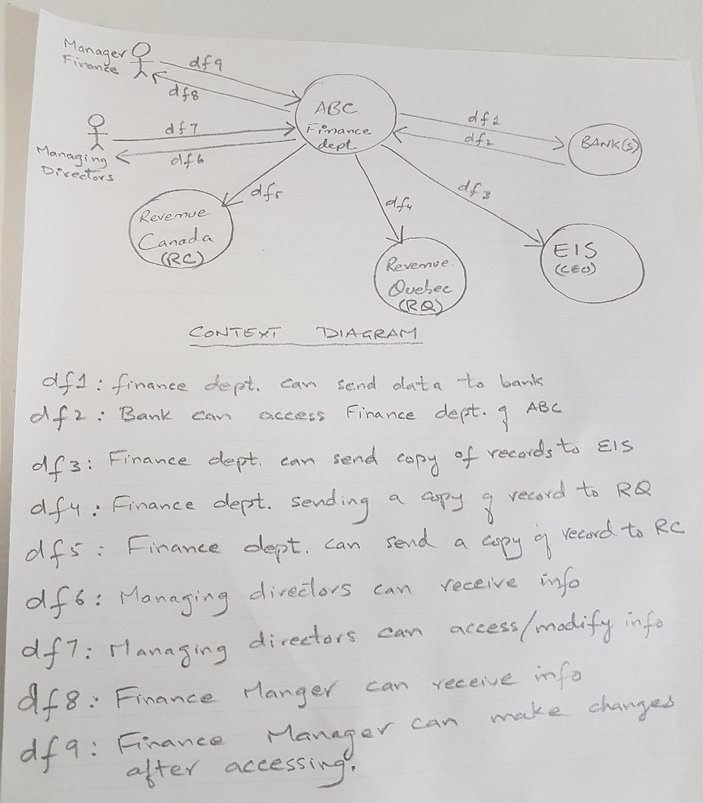

**Scenario for Use Case Diagram**

There is a software named ‘AIS’ which is being used in a company named Super-Tech. The ‘AIS’ contains sub modules called Supply, Inventory, Finance, Marketing, HR, Manufacturing. The concerned Managers of each department can access the major activities of each module. The major activities are, for Supply; ‘Supply Order’, for Inventory; ‘Check Inventory’, for Finance; ‘Access Financial Reports’, for Marketing; ‘Develop Marketing Strategy’, for HR; ‘Get Bonus’, for Manufacturing; ‘Manufacture Order’. Moreover, CEO of ‘AIS’ can access the major activities of modules as Managers do. Usually the main tasks/activities within the modules are done by the clerks. We really need to take care of one thing that before we manufacture any order, we need to check the inventory as well.

Develop the basic Use Case Diagram.

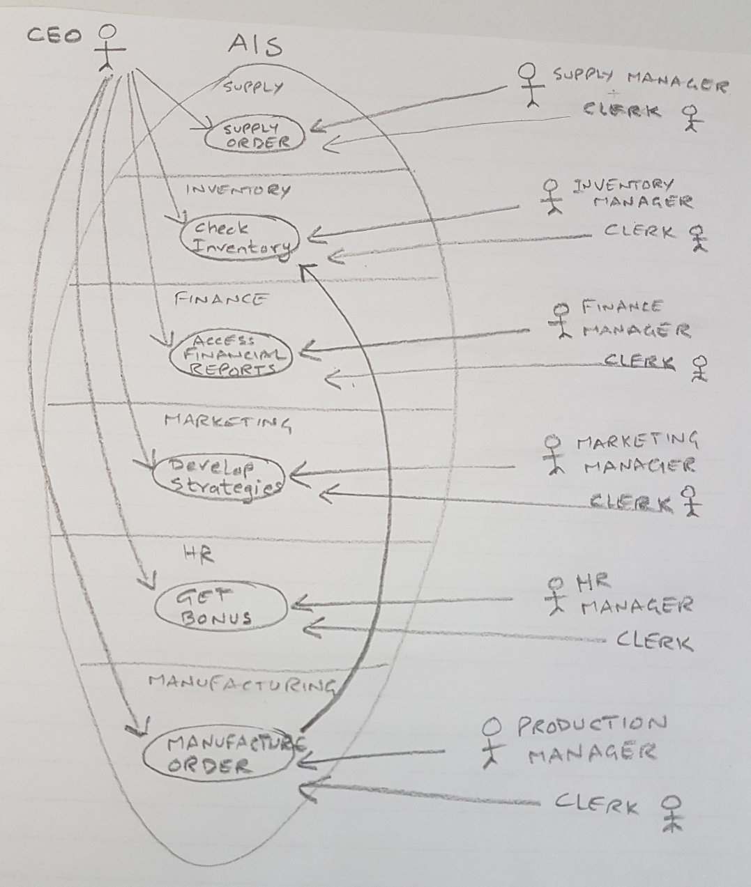

**Scenario for Event Table**

The student registration system for the Advanced Technology Institute accepts registrations in person and over the internet.   
Each person wanting to register as a student, files an application form which is then reviewed by the Institute staff.   
Once approved, the applicant is contacted and required to pay 50% of the admission fee.   
Once the fee is paid, the course texts are made available and the schedule for the courses are issued to the applicant.

Please do not assume anything – deal only with what is stated.

EVENT TRIGGER SOURCE USE CASE RESPONSE DESTINATION

|  |  |  |  |  |  |
| --- | --- | --- | --- | --- | --- |
| Person wants to register as student | Submission of Application form | Person; applying to be a student | Application Review by Institute staff | Approved, Request for 50% of admission | Person applying to be a student & Dept. |
| Person wants to pay 50% | Fee Payment; 50% | Person; applying to be a student | Make texts and schedule available | Send texts and schedule | Person applying to be a student & Dept. |

Given the text above, this Event Table describes what is known without making various assumptions. However, with further discussion with the client, of the narrative and its representation in the Event Table, further detail might be made available allowing Event Table entries at more detailed levels of abstraction.